States of Matter Questions

Q1.
The diagram shows a model of the particles in a gas and in a liquid.
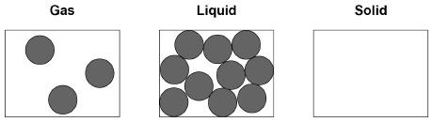
(a) Complete the diagram to show the arrangement of particles of the same substance as a solid.
(2)

(b) What is the name of the process when a substance changes from a gas to a liquid?
Tick one box.

Condensing | 
Evaporating | 
Freezing | 
Melting | 
(1)

(c) The substance in the diagram has a:
• melting point of 98 °C
• boiling point of 883 °C
What is the state of the substance at 20 °C?
Tick one box.

Gas |  | Liquid |  | Solid | 
(1)

(d) What type of change is a change of state?
Tick one box.

Chemical | 
Kinetic | 
Permanent | 
Physical | 
(1)
(e) Which two statements are correct about the particles when a liquid turns into a gas?
Tick two boxes.

Particles are bigger | 
Particles are lighter | 
Particles have more chemical energy | 
Particles have more kinetic energy | 
Particles move faster | 
(2)

Q2.
Ice was heated at a constant rate. Eventually all the ice changed to a gas. This graph below shows how the temperature changed over 800 seconds.
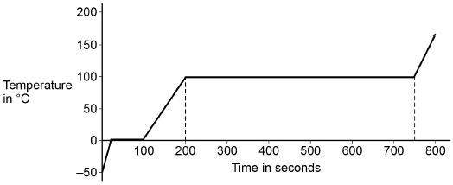
(a) What change of state occurs between 200 seconds and 750 seconds?
___________________________________________________________________
___________________________________________________________________
(1)
(b) Explain how the graph shows that the energy needed for vaporisation is greater than the energy needed for melting. Use data from the graph
___________________________________________________________________
___________________________________________________________________
___________________________________________________________________
___________________________________________________________________
(2)

Q3.
Rock salt is a mixture of sand and salt. Salt dissolves in water. Sand does not dissolve in water. Some students separated rock salt. This is the method used.
1. Place the rock salt in a beaker.
2. Add 100 cm³ of cold water.
3. Allow the sand to settle to the bottom of the beaker.
4. Carefully pour the salty water into an evaporating dish.
5. Heat the contents of the evaporating dish with a Bunsen burner until salt crystals start to form.
(a) Suggest one improvement to step 2 to make sure all the salt is dissolved in the water.
___________________________________________________________________
___________________________________________________________________
(1)
(b) The salty water in step 4 still contained very small grains of sand.
Suggest one improvement to step 4 to remove all the sand.
___________________________________________________________________
___________________________________________________________________
(1)
(c) Suggest one safety precaution the students should take in step 5.
___________________________________________________________________
___________________________________________________________________
(1)
(d) Another student removed water from salty water using the apparatus in the figure below.
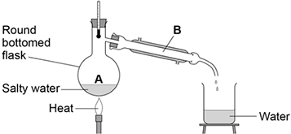
Describe how this technique works by referring to the processes at A and B.
___________________________________________________________________
___________________________________________________________________
___________________________________________________________________
___________________________________________________________________
(2)
(e) What is the reading on the thermometer during this process?
__________________ °C
(1)

Q4.
(a) The box gives some methods used in the separation of mixtures.
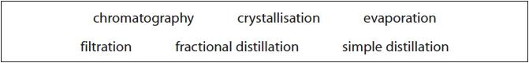
Use words from the box to answer these questions.
(i) Identify the method used to obtain pure water from sea water.
(1)
.............................................................................................................................................
(ii) Identify the method used to separate the dyes in a food colouring.
(1)
.............................................................................................................................................
(iii) Identify the method used to obtain ethanol from a mixture of ethanol and water.
(1)
.............................................................................................................................................

(b) Complete the sentences by writing a suitable word in each blank space.
(3)
When salt is added to water and stirred until no more will ................................................., a saturated solution forms.

The salt is the ............................................................................................. .

The water is the ............................................................................................. .

